

**Title: Visualization of binary search**

**using real life examples**

*Design Thinking Lab Report*

*(18IS47)*

## Submitted by



### ARPIT VERMA 1RV20IS011

### DHISHA S BABU 1RV20IS016 HITESH BELEKERI 1RV20IS019

### RAKSHITH HEGDE 1RV20IS038

**Under the guidance of**

Dr. Rajashekhara Murthy Prof. S G Raghavendra Prasad

Associate Professor Assistant Professor

Dept. Of ISE, RVCE Dept. Of ISE, RVCE

### In partial fulfillment of the requirements for the degree of

### Bachelor of Engineering

### in

**Information Science and Engineering**

**2021-2022**



**RV COLLEGE OF ENGINEERING®, BENGALURU-59**

(*Autonomous institution affiliated to VTU, Belagavi*)

### Department of Information Science and Engineering

.

**CERTIFICATE**

Certified that the Design Thinking Lab project titled **Visualization of binary search using real life examples carried out by Arpit Verma (RV20IS011), Dhisha S Babu (1RV20IS016), Hitesh Belekeri (1RV20IS019) and Rakshith Hegde (1RV20IS038)** who are the bonafide students of RV College of Engineering, Bengaluru, in partial fulfillment of the requirements for the degree of Bachelor of Engineering in Electronics and Communication Engineering of the Visvesvaraya Technological University, Belagavi during the year 2021-2022. It is certified that all corrections/suggestions indicated for the Internal Assessment have been incorporated in the Design Thinking Lab report deposited in the departmental library. The Design Thinking Lab report has been approved as it satisfies the academic requirements in respect of Design Thinking Lab work prescribed by the institution for the said degree.

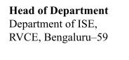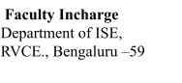

#### 

**DECLARATION**

We, **Arpit Verma (RV20IS011), Dhisha S Babu (1RV20IS016), Hitesh Belekeri (1RV20IS019) and Rakshith Hegde (1RV20IS038)**, students of fourth semester B.E., Department of Information science and engineering, RV College of Engineering, Bengaluru, hereby declare that the Design Thinking Lab projecttitled **‘Visualization of binary search using real life examples’** has been carried out by us and submitted in partial fulfillment for the award of degree of **Bachelor of Engineering** in **Information Science and Engineering** during the year 2021-2022.

Further, we declare that the content of the report has not been submitted previously by anybody for the award of any degree or diploma to any other university.

I also declare that any Intellectual Property Rights generated out of this Design Thinking Lab carried out at RVCE will be the property of RV College of Engineering, Bengaluru and we will be one of the authors of the same.

Place: Bengaluru Date:

Name Signature

Arpit Verma (1RV20IS011)

Dhisha S Babu (1RV20IS016)

Hitesh Belekeri (1RV20IS019)

Rakshith Hegde (1RV20IS38)

**ACKNOWLEDGEMENT**

The completion of this report could not have been possible without the assistance and guidance

of our professors, Raghavendra Prasad and Rajashekara Murthy. We cannot express enough

thanks for his continued support and supervision throughout this undertaking. We would also like

to express our deep sense of gratitude towards our HOD, Dr B.M Sagar, and Principal,

Dr K N Subramanya for giving us this opportunity and for their guidance in the completion

of our report. Lastly, we would also like to thank all the faculty members for their

constant encouragement and cooperation.

**TABLE OF CONTENT**

|  |  |  |
| --- | --- | --- |
| **Sl. No.** | **Topic** | **Page Number** |
| **1** | **Perspectives and Building Blocks** | **6** |
| **2** | **Technology and Systems** | **6** |
| **3** | **Optimization and Soft Computing Methods** | **7** |
| **4** | **Emerging Trends in Improving Education through ICT** | **8** |
| **5** | **Case Study: Empathy** | **10** |
| **6** | **Case Study: Define** | **17** |
| **7** | **Case Study: Ideate** | **20** |
| **8** | **Case Study: Prototype** | **23** |
| **9** | **Testing** | **29** |
| **10** | **Conclusion** | **30** |
| **11** | **References** | **30** |

**1. PERSPECTIVIES AND BUILDING BLOCKS**

## A synchronous circuit in digital electronics is a digital circuit in which a clock signal synchronizes changes in the state of memory elements. In a circuit for sequential digital logic, data are kept in memory components known as flip-flops or latches. A string (sequence) of pulses known as the "clock signal" is produced by an electronic oscillator known as the clock in a synchronous logic circuit. The clock distribution networks must be carefully designed in order for these circuits to function properly.

## State tables are tables that plot the performance of a sequential circuit against stable internal circumstances (states) and input variables. If every feasible combination of inputs results in exactly the same output and the same future state, then two states are said to be equivalent. State-reduction algorithms focus on techniques for lowering the number of states in a state table while maintaining the consistency of the external input-output requirements.

## The addition of duplicate states is typically avoided via the state reduction technique. Reduced redundant states result in fewer flip-flops and logic gates, which lowers the final circuit's cost.

## 2. TECHNOLOGY AND SYSTEMS

Simulators for state table reduction methods are not accessible online. There aren't even any internet calculators for the same. There are numerous websites and blogs about various State table reduction methods, but they are more concerned with Theory of Computation than Circuit Design. There are a few videos accessible in YouTube specific to state table reduction uploaded by NPTEL.

**3. OPTIMIZATION AND SOFT COMPUTING METHODS**

The majority of the already accessible technologies emphasize gamifying instruction and employ multimedia and animated movies to engage pupils.

But none of these expose pupils to real-world learning. The following are a few ways that the current technology could be improved:

a. Making use of interactive interfaces that let students virtually participate in the experiment or topic they are working on. These enable the student to gain practical experience and improve their understanding of the subject.

b. Simulators that aid students in comprehending each stage of a difficult procedure.

These simulators can also assist students who are struggling with a problem and having trouble coming up with solutions.

c. Resources that have been carefully chosen to serve as a one-stop shop for any problems a student might encounter. Videos, notes, links to practice issues and sample problems are a few examples.

d. In order to maintain students' interest, more creative and innovative lesson plans can be created by incorporating modern technologies into the classroom, such as artificial intelligence.

Gamification of the classroom can help students finish their assignments on time and without getting bored.

e. Instead of using traditional exam patterns that strongly emphasize memorization of solutions and problem-solving strategies, virtual systems' capabilities can be used to create examinations that are more robust, entertaining, and focused on a student's technical expertise.

f. Pre-existing technologies can be customized personally. These adaptations enable these technologies to be tailored and molded to the requirements of every single learner. As a result, the student is more at ease utilizing these tools, able to focus specifically on their areas of weakness, and progress at their own rate of learning.

**4. EMERGING TRENDS IN IMPROVING EDUCATION THROUGH ICT**

The currently emerging trends in ICT applied to education are as follows:

1. Mobile learning: New hardware and software developments have made mobile "smart phones" essential learning tools. Similar to how mobile devices with internet access and computing capabilities have surpassed fixed line technology in the telecommunications sector, it is likely that these devices will soon displace personal computers as the preferred information appliance in classrooms.

2. Cloud computing: More and more applications are leaving isolated desktop computers in favour of server farms that can be accessed online. This trend will result in the availability of less expensive information appliances that do not need the size or processing capacity of a PC, which will have significant ramifications for educational systems. Providing ubiquitous connectivity to access data stored in the "cloud" will be the problem.

3. Gaming: The extraordinary popularity of games that emphasise active involvement, built-in incentives, and interaction indicates that present educational approaches are beneficial and that educational games could better pique students' interest and focus.

4. Personalized learning: Educational systems are examining the use of technology to better understand a student's prior knowledge base and to modify instruction to address both learning gaps and learning preferences. With this focus, a classroom is transformed from one that teaches to the middle to one that adapts content and methodology based on each student's unique requirements, both strong and weak.

5. Use of Virtual Reality and Augmented Reality: Learning has become much more immersive than it was before the advent of Virtual Reality and Augmented Reality. Students can now examine upgraded versions of the image and objects on their mobile devices, in contrast to plain photographs and practical lab exercises.

**5. CASE STUDY**

**1. Empathy**

1.1 Introduction to Empathy

When an individual puts aside their perception of a situation and looks at it from another person’s eyes, it is known as empathy. We can see, feel, and experience a situation from someone else’s perspective. Through empathy, we can understand their ideas, thoughts, and needs. Of course, we cannot experience the situation exactly as another person would, but understanding their point of view to the best of our ability is essential to building an empathetic approach to solutions.

Often confused with the word empathy, sympathy is more about one’s ability to show concern for an individual’s experience. It does not necessarily require one to experience deeply for the other person. Sympathy also involves a sense of detachment and projection of pity and sorrow for the other person. This feeling of sorrow or pity may not sit well with individuals and is not beneficial in the design thinking approach.

Empathy is considered the starting point for any design project, and constitutes phase one of the Design Thinking process. During the empathize phase, the designer spends time getting to know the user and understanding their needs, wants, and objectives. This means observing and engaging with people in order to understand them on a psychological and emotional level. When we approach a problem with empathy, we can deduce issues that the user may not even be aware of.

Uncovering hidden problems is one of the greatest strengths of design thinking. Empathy helps in appreciating people's emotional and physical needs, gain insight into the way people see, understand and interact with the world around them, realize how lives are impacted within the contexts being investigated, finds what people mean rather than just what they say — empathic research is inherently subjective and is concerned with motivations and thoughts, rather than facts.

1.2 Customer Persona and Environment

Name: Sandeep

Occupation: Student

College/Branch: RV College of Engineering, Information Science

Age: 19

About: Sandeep is a student in RV college of engineering, majoring in Information science. Jacob has the course algorithms as part of the curriculum in his 2nd year. He has to understand, analyze and visualize how every algorithm works, and where to use them. He also has various searching algorithms such as linear search, binary search, interpolation search, jump search, exponential search etc. in his syllabus.

Behavior:

* Is a visual learner
* Finds self-learning more efficient
* Has less concentration power
* Curious to learn and apply new topics
* Loves problem solving

Goals:

Sandeep wants to

* Have clear conceptual grasp of algorithms
* Understand the algorithms
* Be able to visualize iterations
* Be able to solve miscellaneous questions
* Correlate it with real life examples

Customer Environment

Sandeep’s teachers use classic methods of teaching, due to which he finds difficulty in having a complete understanding of topics. Lack of learner-centered teaching methods, memorization of algorithms, lack of visualization, lack of interactive or participative methods are observed in his classroom.

1.3 Customer Empathy Map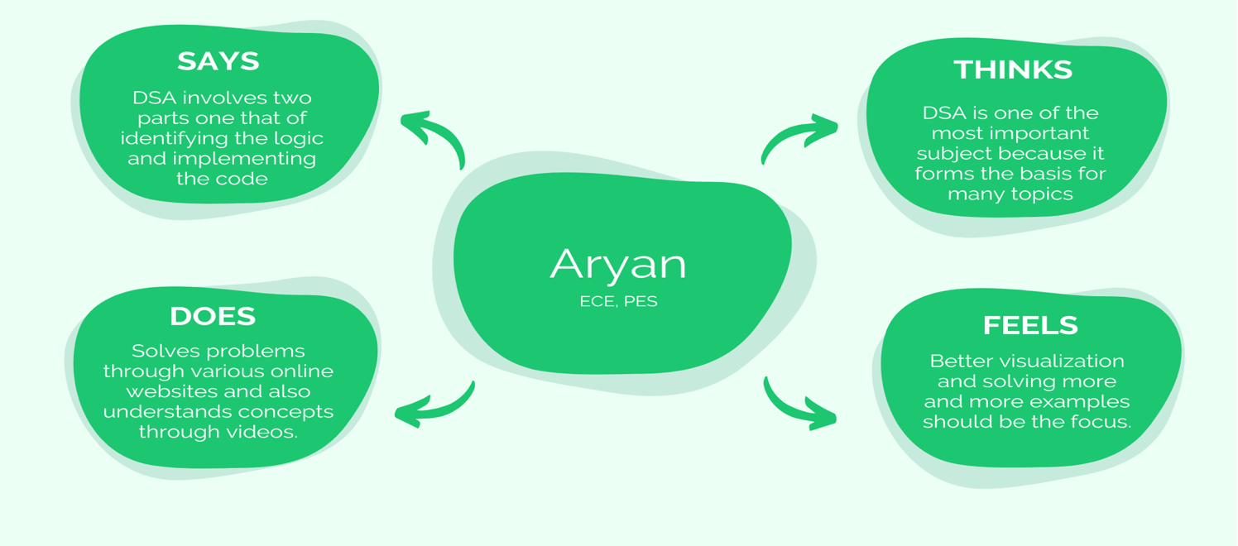

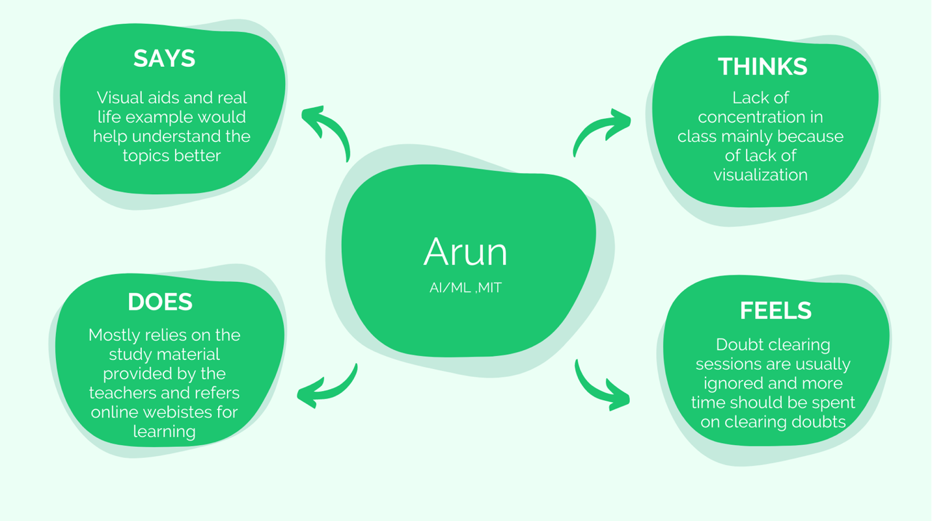

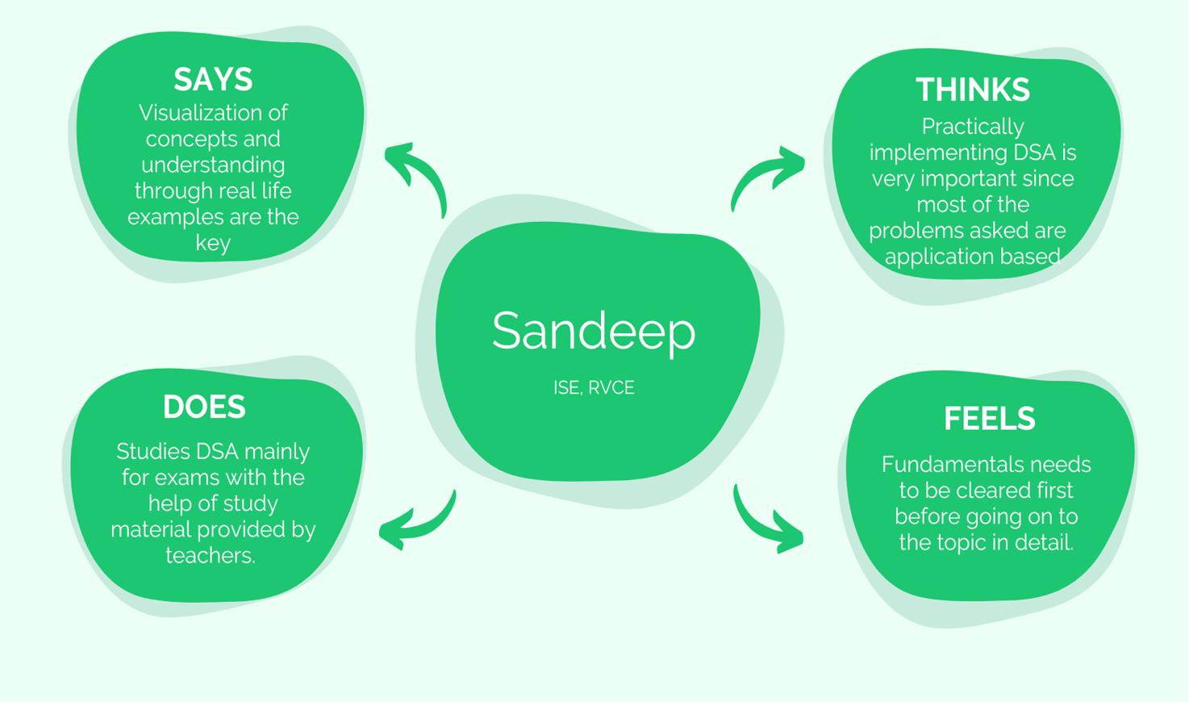

1.3 Customer survey and analysis

Sample client details and Base/End user

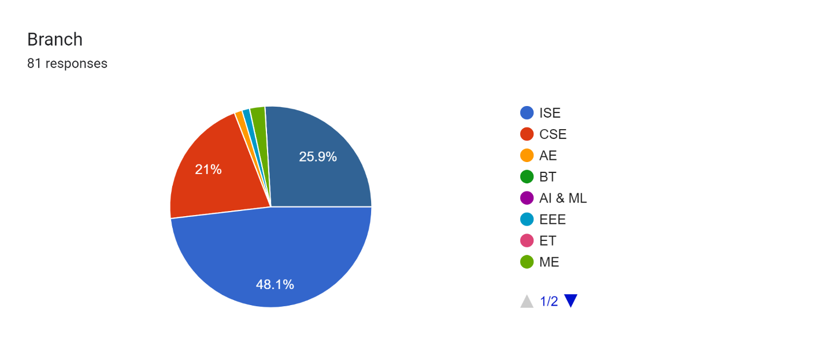

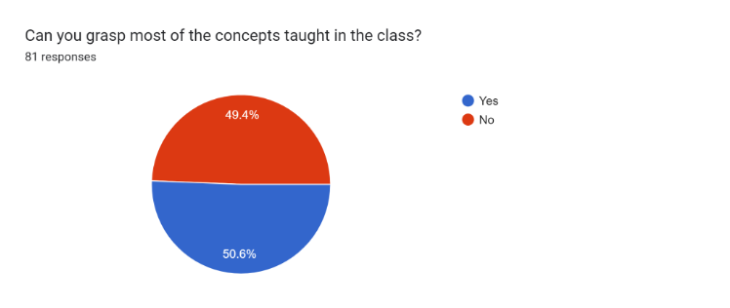

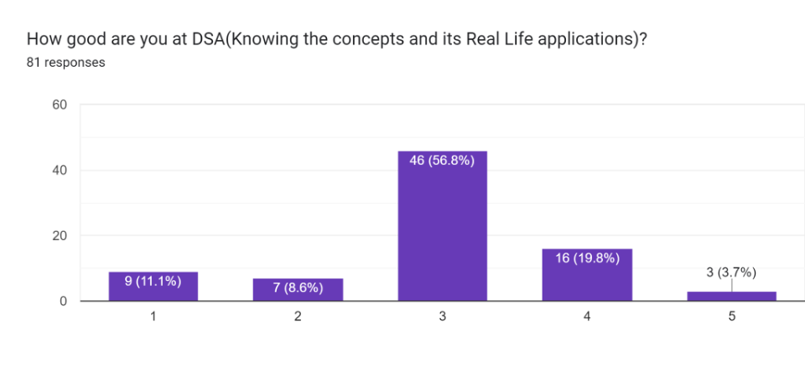

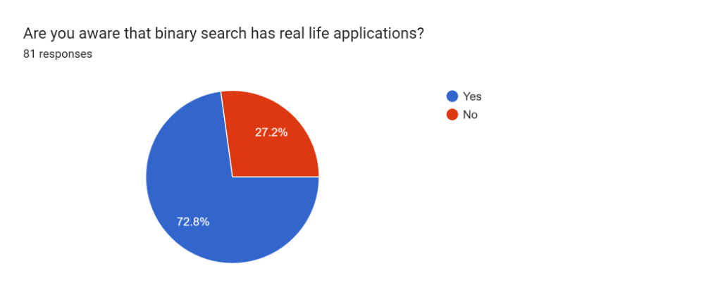

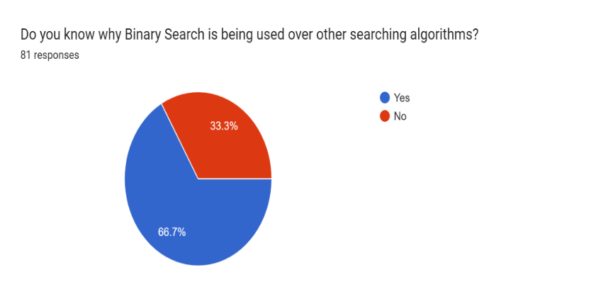

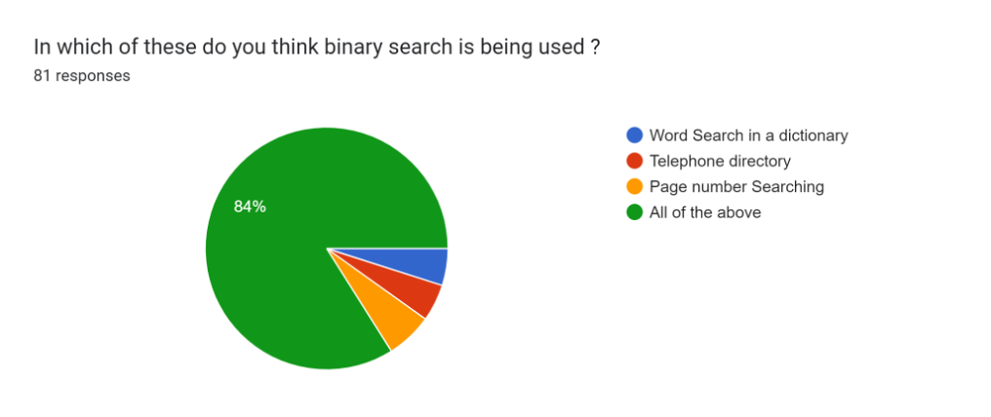

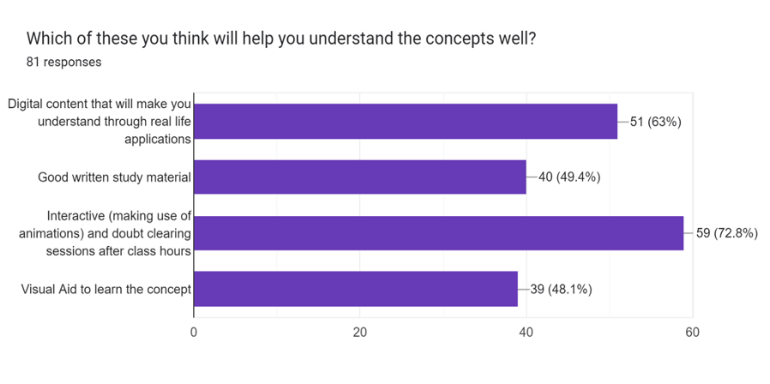

Feedback from students

1. Learning should happen through practical examples rather than Theory
2. Interactive, Digitalized content should be used more rather than conventional teaching methods
3. More time should be given for self-study as that would give time to explore the topic in depth
4. More and more projects have to be done in order to make learning easier.

**2. Define**

2.1 Introduction to problem definition

The aim of this project is for students to easily learn the concept of Binary Search and faculties to teach the students more effectively. Data Structures being a hard to learn subject for some students, it’s good to bring about a simpler way of teaching the concepts which is in benefit of both Teachers and Students. Focusing on the practicality of the subject matter rather than exam oriented rote learning is one of the main motives.

Students find it easier to grasp the concept more effectively by using alternative learning methods such as visualization. Animated videos, mind maps, charts, diagrams etc., are some of the ways in which students can enhance their visualization skills. There is a lack of Interactive methods to engage students and draw their attention to the concepts. Problem-based learning, Project-based learning in which students acquire a deeper knowledge through active exploration of real-world challenges and problems.

Simulations and role play is a form of experiential learning which can be very motivating, helping students to connect their learning to real world outcomes and to practice skills they will need in order to apply their knowledge. ​Work integrated learning​ students apply their academic learning to its practical application in the workplace. Flipped classroom models refers to the idea of getting students to learn “content” in their own time, and to apply the content during class time. Thus, in our solution to this problem we aim to address these issues, and make binary search easily understandable and fun.

2.2 How might we question

List of questions asked to students

* Do you find any difficulty in understanding the concepts of the subject Data structures and algorithms?
* Are you able to understand the concepts when taught in class?
* To what extent are you able to grasp the topic when taught for the first time in class?
* Do you prefer self-learning or you would prefer learning from teachers?
* Do you use additional resources to get hold of the topic?
* How well will you be able to explain the topic to a 10-year-old?
* Do you think visual learning is better than classic methods of learning?
* Do you watch YouTube videos to learn better?
* Do you feel the lack of useful resources for learning algorithms?
* Are you able to implement concepts of algorithms?
* Do you think teaching with real life applications and interactive content will be of any help to you?
* Do you think lacking in understanding of fundamental concepts is one of the main problems hindering learning?
* What are the learning methods you find useful while learning Algorithms?
* Are you able to understand the bigger picture of the topics in the algorithm, its current application?
* Are you able to understand the logic behind every algorithm?
* Are you able to understand which algorithms to use in a given problem?
* Are you able to solve problems related to algorithms?
* How many searching algorithms are you aware of?
* Can you explain briefly what binary search algorithm is?
* Tell us some real-life examples where binary search can be used?
* What are the advantages and disadvantages of binary search algorithm?
* What is the divide and conquer method of solving algorithms?

List of questions asked to teachers

* Do students pay attention in class while explaining concepts?
* Do you think all the students are able to understand the topic well?
* What are the teaching methods you find useful?
* Are students able to perform well in the class tests?
* What are the difficulties you face while teaching?
* Are the teaching hours enough for explaining the whole concept in depth?

**3.** **Ideate**

3.1 Introduction to ideation

Ideation is the third phase of the Design Thinking process, and it’s all about generating ideas. The ideation phase represents a key transitional step from learning about your users and the problem, to coming up with solutions. In the ideation phase, you’ll explore and come up with as many ideas as possible. Some of these ideas will go on to be potential solutions to your design challenge; some will end up on the reject pile. At this stage, the focus is on quantity of ideas rather than quality. The main aim of an ideation session is to uncover and explore new angles and avenues—to think outside the box. For the sake of innovation and creativity, it is essential that the ideation phase be a “judgment-free zone”.

3.2 Ideation technique/s used and description

* Brainstorming

Brainstorming is a method of generating ideas and sharing knowledge to solve a problem. The defining characteristics of a good brainstorming session are when participants are encouraged to gather ideas spontaneously and to think without interruption. When done as a group, people typically collectively agree upon a solution after all the ideas are brought forth and discussed, but it can also be done individually. The technique of brainstorming is often used in problem solving. Brainstorming allows us to think critically about ideas and solutions, form connections, and share ideas with peers. The activity allows exploring and expanding 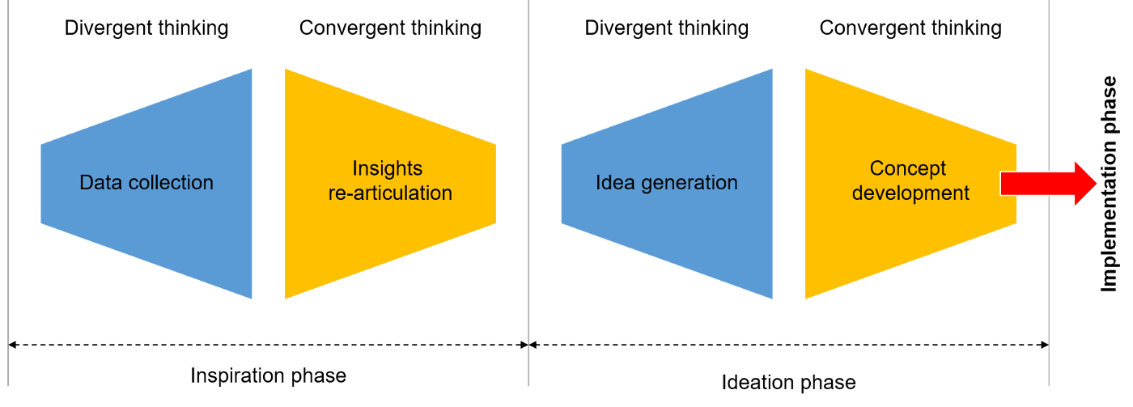a person’s ability to think critically and laterally.

3.3 Ideation process followed

1. Generation of ideas

* Creating animations

The use of animation in education facilitates educators and learners in a variety of ways. Not only it assists learning but also gives educators freedom to use a combination of teaching methodologies. They can quickly pick-up an animated video about a topic and show it to the learners for better understanding.

* 3-D Interactive simulations

Animation makes it possible to turn abstract concepts and processes into something tangible and relatable. Visual stimuli can trigger an emotional response – which together forms a memory. The more that learning engages our long-term memory, the better our overall achievement is

* Virtual reality

Virtual reality can be used to enhance student learning and engagement. VR education can transform the way educational content is delivered; it works on the premise of creating a virtual world — real or imagined — and allows users not only see it but also interact with it. Being immersed in what you’re learning motivates you to fully understand it. It’ll require less cognitive load to process the information.

* Conceptual explanation using storytelling

Good stories do more than create a sense of connection. They build familiarity and trust, and allow the listener to enter the story where they are, making them more open to learning. Good stories can contain multiple meanings so they're surprisingly economical in conveying complex ideas in graspable ways

* Smart board sessions

Interactive whiteboards integrate various learning styles into one experience. Students can learn by seeing, hearing, and interacting with the board through touch. This equips teachers with new, innovative ways to teach the same subject material. Because of this, students learn better and remember more.

* Explanation using real life examples

Real-world connections draw from, or upon, actual objects, events, experiences and situations to effectively address a concept, problem or issue. It involves learning that allows students to actually experience or practice concepts and skills, as opposed to learning that is theoretical or idealistic.

2. Evaluation and idea refinement

We decided to choose animation and virtual reality to explain the topic of binary search using real life examples. Animation makes it possible to pair concepts with meaningful images, which in turn goes into our long-term memory. This is a vital addition to more classical forms of learning, as it gives students the opportunity to engage with different types of learning. As no two pupils are the same, providing access to stimulating animated videos is a great way to ensure that all learning styles are catered for.

Furthermore, it’s easier for pupils to process chunks of information when the right visuals are available to support the text. Strong design, supported by a clear narration, can aid student comprehension. As a result, eLearning content has the potential to have more impact than text or audio-based explanations.

**4. Prototype**

One of the best ways to gain insights in a Design Thinking

process is to carry out some form of prototyping. This method

involves producing an early, inexpensive, and scaled down version of

the product in order to reveal any problems with the current design.

Prototyping offers designers the opportunity to bring their ideas to life,

test the practicability of the current design, and to potentially

investigate how a sample of users think and feel about a product.

4.1 Options available for prototyping

* Using Animated videos with real life examples to give

students a higher sense of understanding. The video should

be interactive and easy to understand.

* Teaching Videos- Teach a concept on paper, record it and

send it to students for further reference.

4.2 Prototype selected and reasons

We’ve gone on to make an animated video which uses real life

examples so the students find it more interesting and intuitive.

Our reason for selecting this video was based on the research

that we had conducted, in which more than 70% of the students

felt that they’ll be able to grasp the concept more easily if the

learning is interactive with the use of animation and real life

examples.

4.3 Prototype Implementation-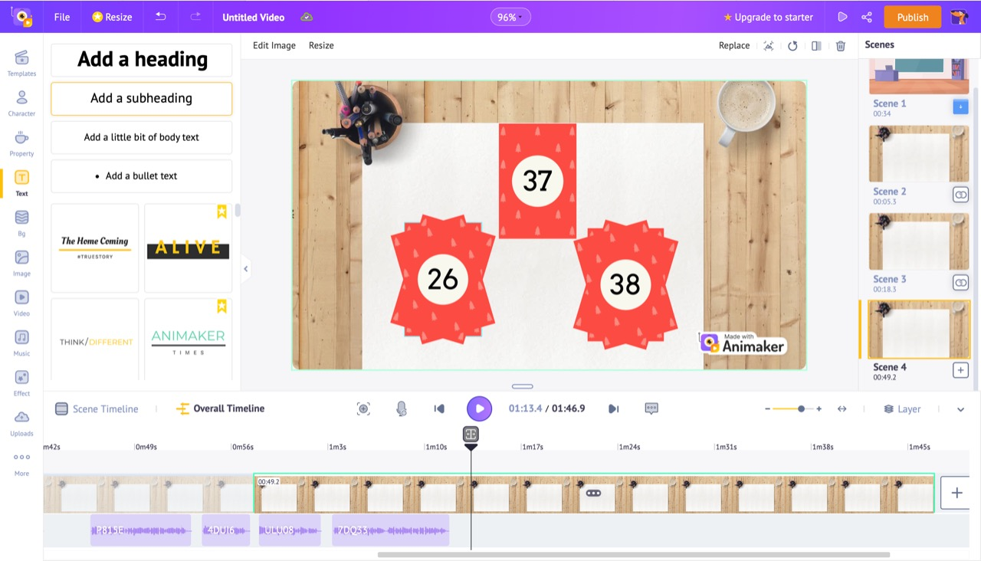

Fig 1. Here we use a real-life example of selecting a card from a deck of cards using binary search.

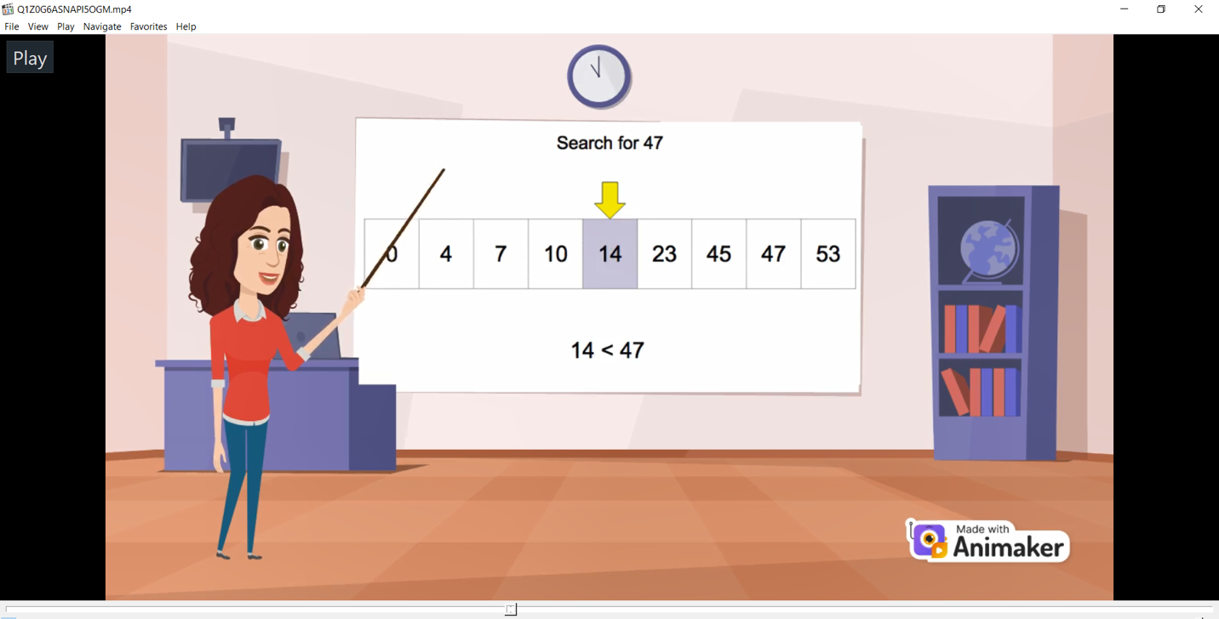

Fig 2. Example is used to give students a better understanding of how the algorithm works.

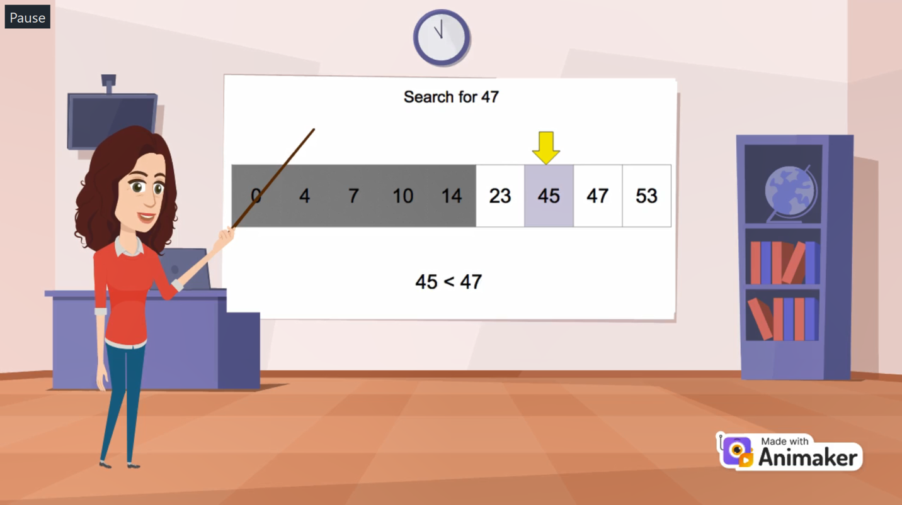

Fig 3. Finally, the answer is found.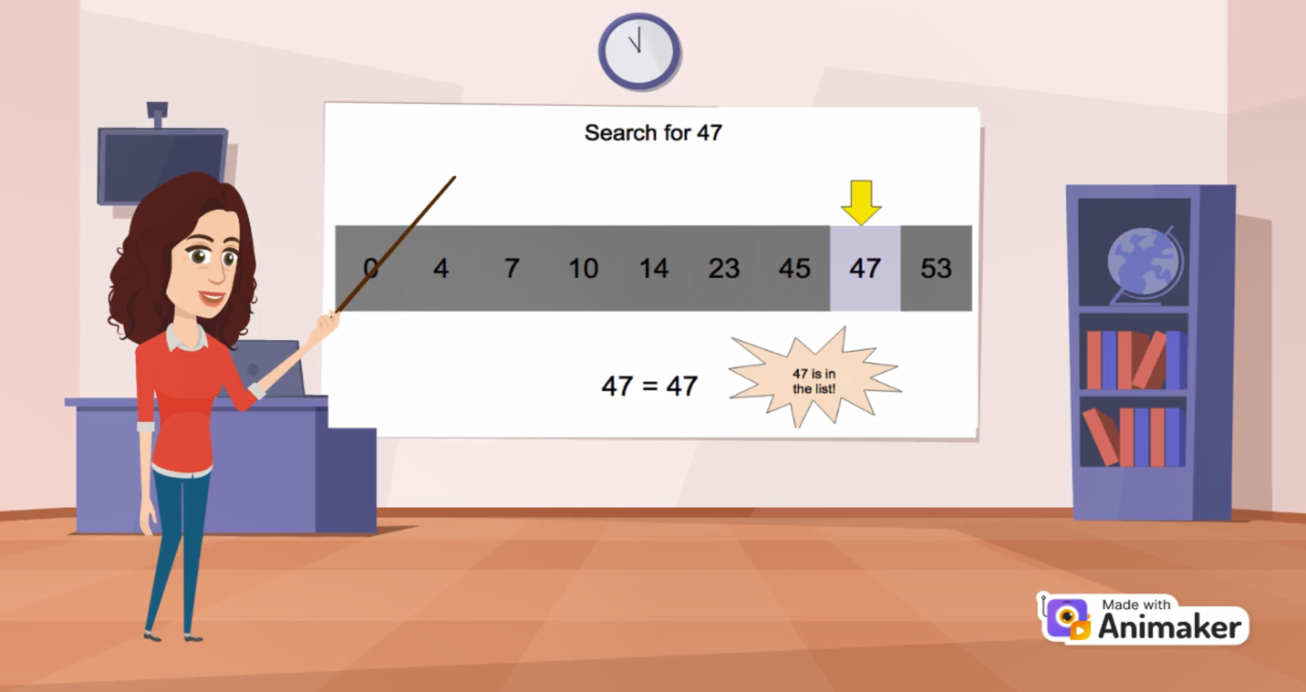

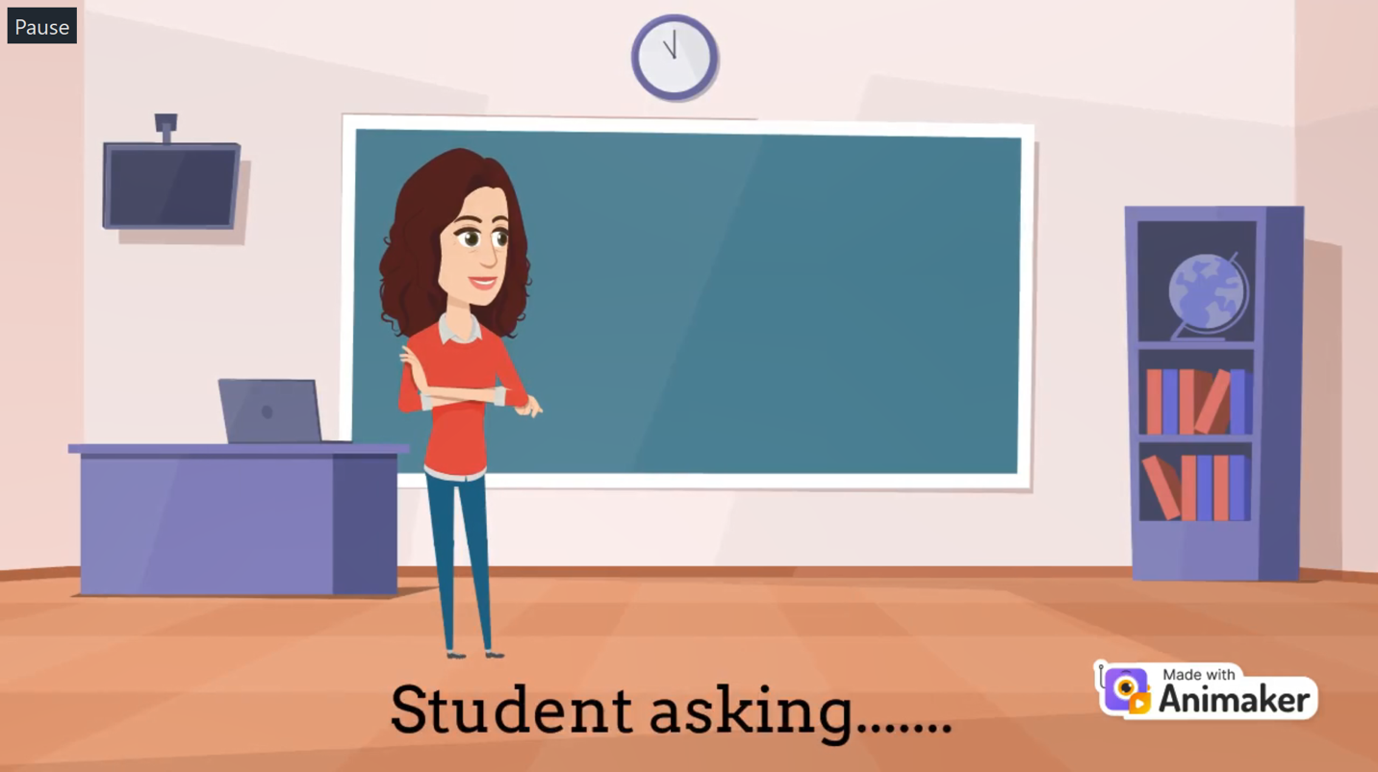



Fig 4. We also added what questions/doubts that students might be having while learning this concept.

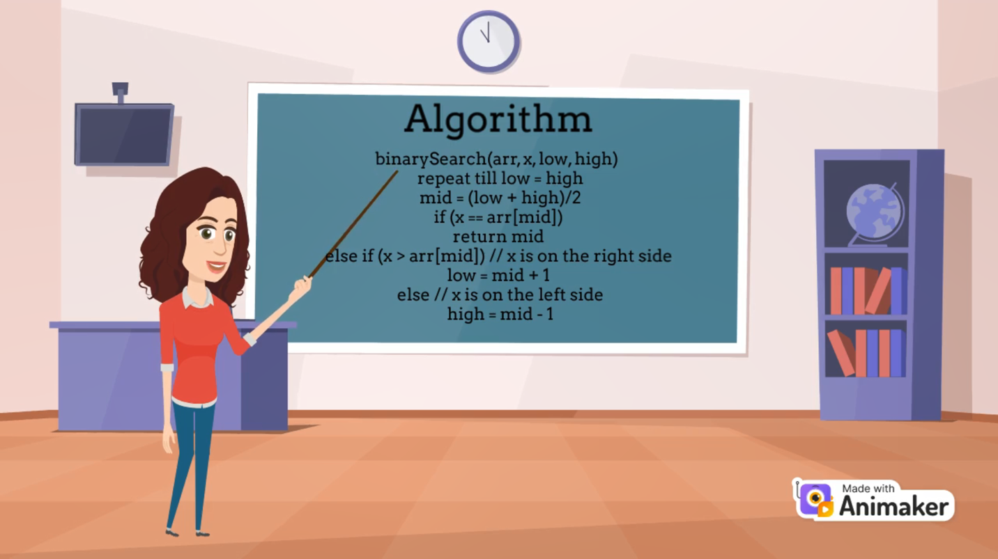

Fig 5. Algorithm explained in depth.

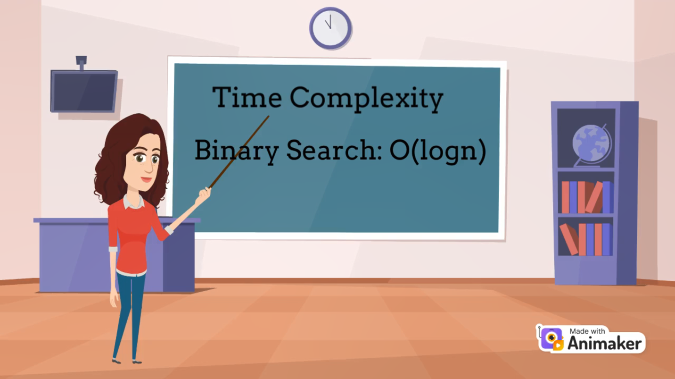

Fig 6. Time Complexity.

**5. TESTING**

This phase is also called as 'Execute’. This is the phase where the final solution is tested on a full-scale basis. The idea that seems the best according to the feedback of the customers and end users in the prototype phase will be executed. In this step, the design thinkers are supposed to be collaborative and agile.

Testing will help to understand what actually works and what does not. This step can be the most rewarding, if the prototypes succeed to give positive results, or can be the most annoying, if the prototype fails. After testing, the entire process of design thinking may have to be repeated. If the end user approves the solution, then the process of design thinking stops here.

5.1 Types of testing

1. Students- We asked our friends to review and suggest changes to make it better.

2. Seniors- We took help from seniors who already know the concept in understanding in what way can the video be more informative and interactive.

Feedback- We showed our prototype to our friends and other students to gain valuable input from them on how to make it better. On interaction students felt that more features like problem solving could be added. The explanation was good, but more content needs to be added. A place to evaluate should also be included in the project. We also received that if we are able to teach the concept through 3D animation/VR then it’ll be more helpful for the students in understanding the concept. We’ll be working on that for our next phase.

**6. Conclusion**

We still have some work to do for the final work to be ready. We are trying to provide VR experience to the user which will help them to grasp the concept better. We are also trying to add simulation with multiple examples in the VR experience.

**7. References**

* <https://www.geeksforgeeks.org/binary-search/>
* <https://www.javatpoint.com/binary-search>
* <https://www.animaker.com/tutorials>
* <https://github.com/facebookarchive/react-360>
* <https://yongdanielliang.github.io/animation/web/BinarySearchNew.html>